**Level 1: PC Tower Case**

**Outline**

Learn about the internals of a standard PC case by examining physical samples and selecting and labeling images found on-line. Gain deeper knowledge by researching and reporting on specific components.

**Questions**

1. Find one (or more) images that clearly show the internals of a PC Tower Case.   
   (i.e. Google images using keywords “PC Case Internals”)

1. Clearly label the following components (using arrows) on your image of the PC case internals:
   1. Motherboard
   2. Power Supply
   3. Hard Disk Drive
   4. Optical Disk Drive (e.g.DVD)
   5. USB Expansion Ports
   6. Monitor Port
   7. Audio Ports
   8. Ethernet Port
   9. Cooling Fan
2. Research more in-depth about “Motherboards”. Make notes on the following:
   1. What different versions are currently available (speed and capacity)

AT Motherboard

ATX Motherboard

ASUS Motherboard

* 1. How the component has changed since the 1980’s  
     They have become better with memory slots, graphic slots etc.

1. Research more in-depth about “Hard Disk Drives”. Make notes on the following:
   1. What different versions are currently available (speed and capacity)

IDE Integrated Drive Electronics

SATA

* 1. How the component has changed since the 1980’s  
     Increased storage and increased RAM

**Level 2: PC Motherboard**

**Outline**

Learn about the structure of a standard PC motherboard by examining physical samples and selecting and labeling images found on-line. Gain deeper knowledge by researching and reporting on specific components.

**Questions**

1. Find one (or more) images that clearly show the layout of a PC Motherboard.   
   (i.e. Google images using keywords “PC Motherboard”)

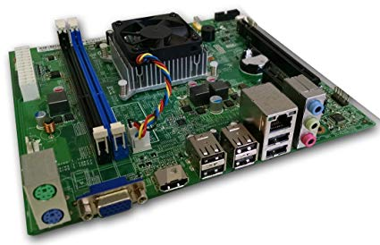

1. Clearly label the following components (using arrows) on your image of the PC motherboard:
   1. CPU (and fan)
   2. RAM Memory
   3. Disk Drive Interface (IDE or SATA)
   4. GPU Graphics Processor (either on-board or Graphics Card)
   5. Sound Processor (either on-board or Sound Card)
   6. Wi-Fi / Ethernet Network Interface (either on-board or Graphics Card)

1. Research more in-depth about “CPU Processor Chip”. Make notes on the following:
   1. What different versions are currently available (speed and capacity)

Budget Processors

Mainstream Processors

Dual-core processors

AMD and Intel processors

* 1. How the component has changed since the 1980’s  
     They have become more advanced and smart. Allowing computer to have advanced features.

1. Research more in-depth about “RAM Memory”. Make notes on the following:
   1. What different versions are currently available (speed and capacity)

Static RAM

Dynamic RAM

**Single** Data Rate Synchronous

**Double** Data Rate Synchronous Dynamic RAM

* 1. How the component has changed since the 1980’s  
     They perform better with better speed and they can handle more storage by running more applications.

**Level 3: Peripheral Devices**

**Outline**

Learn about how peripheral devices are connected to the back side of a typical PC tower case. Examine physical samples, select and labeling images found on-line and gain deeper knowledge by researching and reporting on specific components.

**Questions**

1. Find one (or more) images that clearly show the layout of the back of a typical PC tower case.   
   (i.e. Google images using keywords “Back Of PC Tower”)  
   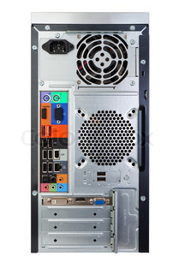
2. Clearly label the following components (using arrows) on your image of the back of a typical PC tower case:
   1. Power cord and power switch
   2. Monitor Interface (VGA or DVI or HDMI)
   3. Mouse Interface (USB or PS/2)
   4. Keyboard Interface (USB or PS/2)
   5. USB Ports
   6. Audio Inputs / Outputs
   7. Ethernet Interface

1. Research more in-depth about “Monitor Technology”. Make notes on the following:
   1. What different versions are currently available (e.g. VGA / DVI, Flat Panel Technology))

CRT

LCD

LED

* 1. How the component has changed since the 1980’s (e.g. Display Resolution, Technology)  
     Better graphics which make games run smoother and look better.

1. Research more in-depth about “External Portable Storage”. Make notes on the following:
   1. Floppy Disks
   2. CD-ROM / DVD / Recordable CD/DVD
   3. USB Memory Drives
   4. Compact Flash Memory
   5. Cloud Based Storage